**Хто такі тінейджери?**

*28.09.2022 9А Хоменко А.Ю.*

**Мета уроку:**

- повторити й узагальнити вивчений лексичний матеріал по темі;

- розвивати навички роботи над індивідуальними та груповими проектами та вміння отримувати інформацію з різних джерел (підручник, Інтернет, додаткова література);

- навчати учнів висловлювати своє власне ставлення до явищ, подій;

- вдосконалювати навички роботи з текстом з метою отримання потрібної інформації для подальшого її використання;

- виховувати толерантне ставлення до інтересів та вподобань інших людей.

Хід уроку.

1. Reading.

**A l e x a n d r a**. A lot of teenagers imitate each other. They talk about the same things, like listening to the same music and wearing the same clothes. If someone dоеs different things, they look at him or her weirdly. As for me that's not good. And as community develops this aspect changes and everyone wants to be special. I like to be original, to have my own style without looking at others. My hobby is foreign languages: English, French and Spanish. Especially I like discussing different issues in English. I like to write for the newspaper and I do an English language heading on Teenage Page in the local newspaper. All these things I can do in the frames of children-youth organization "Commu¬nication without borders". Also I am interested in psychology. I am sure it will be very useful for my future life and job. I don't think I am a typical teenager but I am really fond of music, B-dance and I love communicating with friends like other teenagers.

**A l e x.** A lot of teenagers in our town smoke, some of them drink. I think it is very bad. Teenagers like watching TV and watch it a lot. Very often they have problems: they don't like studying and going to school and their parents and teachers don't understand them. I am interested in computers and I know English language enough to work on Internet and communicate through it. I have been editing Teenage Page in the newspaper "Misto" for three years. Also I am an active member of the youth organization "Communication without borders" and it gives me an opportunity to attend seminars and trainings. I like playing football with my friends.

I think I'm not a typical teenager because I like studying and I have the aim in my life. But like other teenagers I watch TV a lot. When I have time, I go for a walk, play football or dance Break dance.

1. 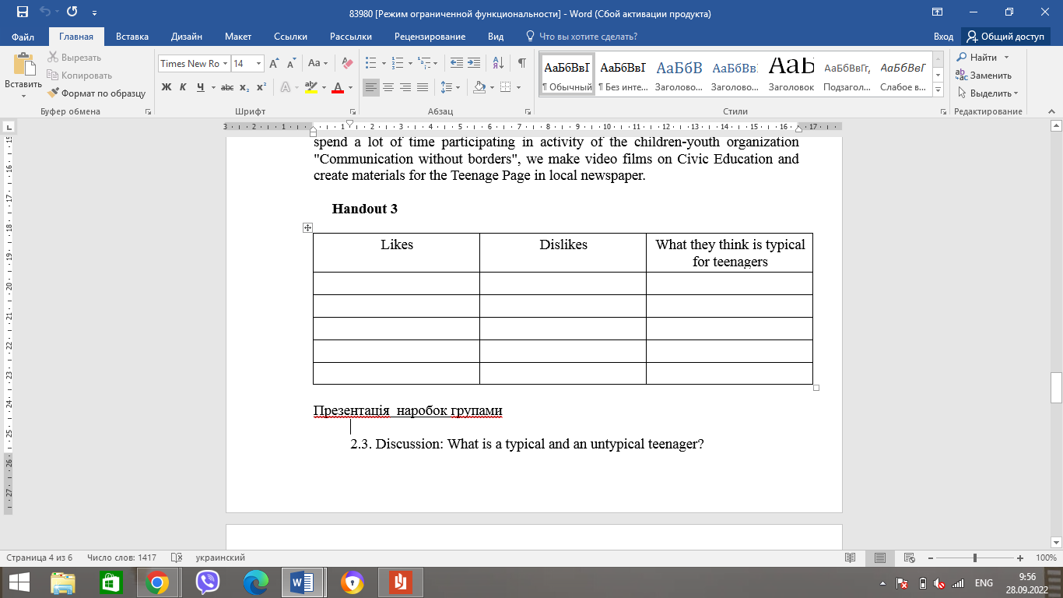Writing. (заповніть табличку, перечитавши тексти)
2. 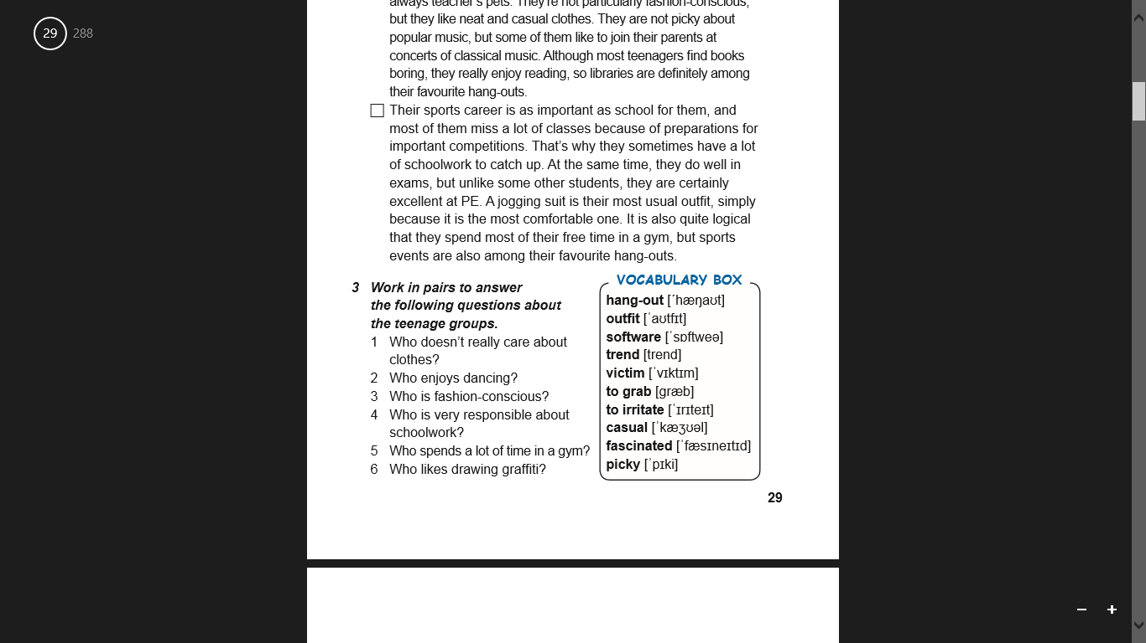Vocabulary. (опрацюйте словничок)

**Home work**: Шановні діти, вам необхідно

* Опрацювати тексти
* Заповнити табличку, використовуючи тексти
* Записати слова в словник, знайти переклад і вивчити.
* Табличку надіслати на Human.